2. Git-HOL

cd ~/GitDemo
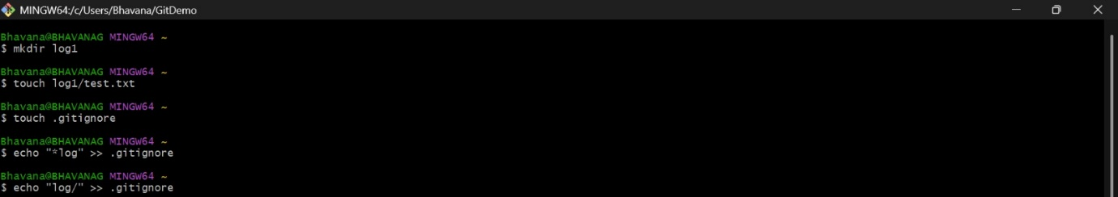
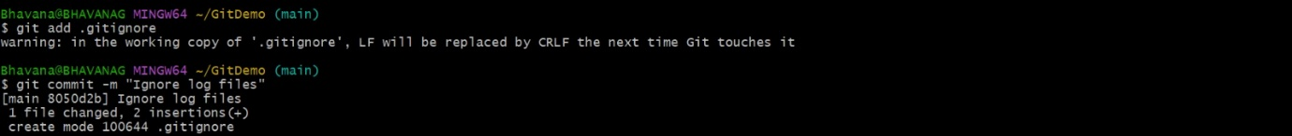

Create test files and folder to ignore
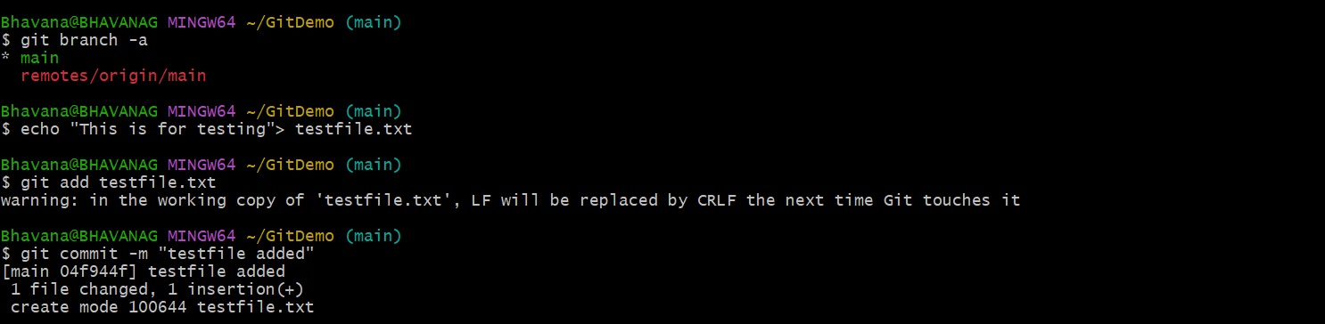
Create a .gitignore file
Touch .gitignore
  - echo "*.log" >> .gitignore
  - echo "log/" >> .gitignore
  - *.log
  - log/

check git status

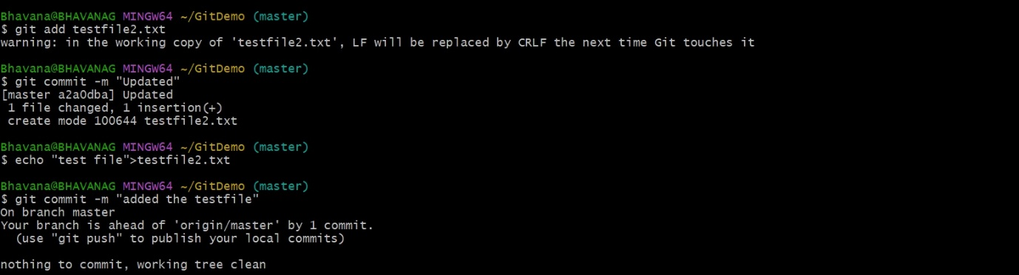
Add and commit only .gitignore
